Houston Visit  
  
To my surprise I am in love with this city.

I`ve been to Houston a few times, but in the past it has only been for work, and I was not able to explore the city. However, in my last visit in July, it was my husband who had to work, so I was finally able to take the opportunity to explore the city with my baby girl.

We had stayed in Houston for 7 days, which we mostly spent at the hotel because it is just impossible to be outside during the Texas summer heat. That was okay though, because my hubby and I are hotel freaks and we love exploring different hotels. We stayed in two different hotels while we visited.

The first hotel that we stayed at was in galleria area. It’s the perfect area for anyone who loves to shop.   
You can find almost any store that you are looking for and enjoy a great dining experience all in the same area.

This was my first time visiting the galleria mall. I was fascinated by not only the size of the mall but also by the fact that there was a hotel located inside the mall that had rooms with a view of the mall from the balcony. We did not get to stay there but it was really cool to see.

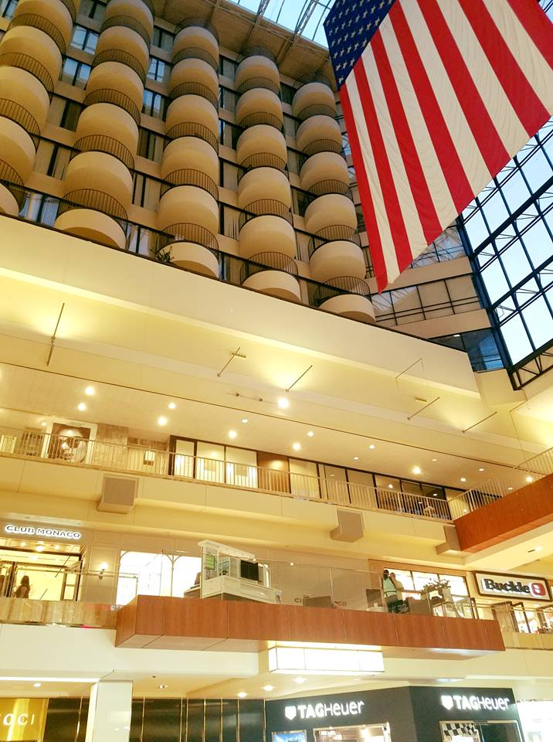  
  
Our second hotel was in Downtown Houston. I was not excited to stay there just because of the chaos that usually goes on in downtown areas but somehow my husband convinced me.

We were lucky enough to have a beautiful room with a view facing downtown Houston at the Le Meridien. It was a very nice and cozy hotel. I liked it because it’s a vintage hotel that just recently went through a fancy remodeling which made it very nice to visit. The only bummer was that this hotel didn’t have a pool but it wasn’t too bad because there was a very cool rooftop bar with an amazing view.  
  
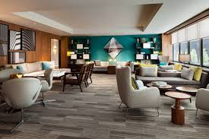

I have been to many downtown areas before and I was impressed by downtown Houston.

It was very unique, clean, and interesting. It had it’s shady areas like every downtown does, but it was not scary at all to walk around and enjoy the city. There was also a good amount of construction being done to make the city even more attractive.

My favorite part of the town was graffiti walls. I am obsessed with graffiti walls.

There were so many and I was not been able to make it to most of them because I was with my new born baby and it was extremely hot, but we made it to one that was close to our hotel.

It was a huge block with 6 beautiful graffiti paintings. My two favorite were "dream big" & "made in Texas", and I absolutely had to take a photo there with my baby girl.  
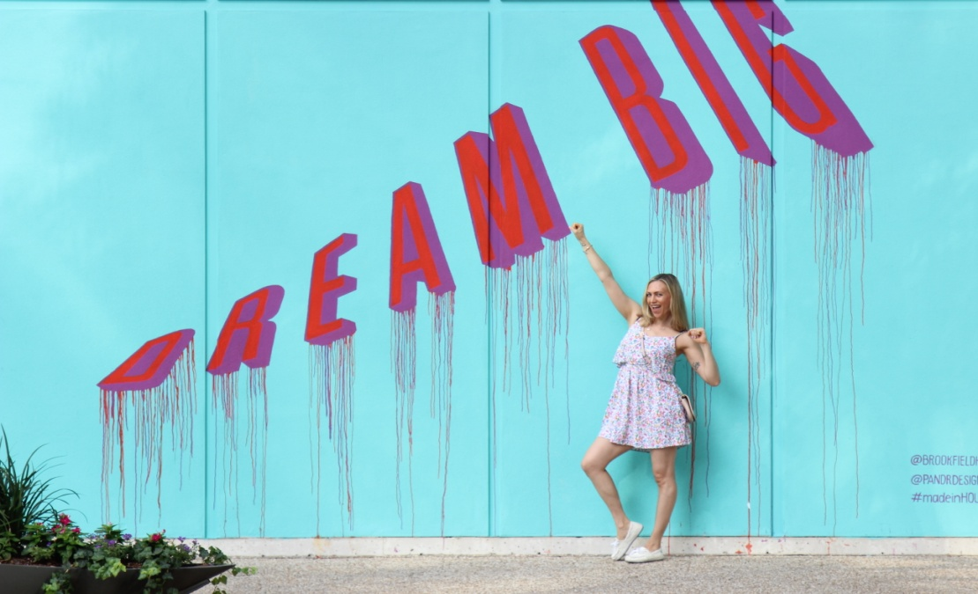  
You can find it right on (location)  
  
My second favorite part was a huge park named "Discovery Green Park". This park was so beautiful, green, colorful, and it even had WiFi. There was an open air reading space, you could borrow games and balls to play with your family, and you could even rent a kayak and take a ride. There was a lot of green grass where you can chill out. The park offered complimentary live concerts, movie nights, and free yoga. Moreover, there was a fun fountain where kids can go wild a cool down splashing in the water.

(photo)  
  
If you a blogger or just someone who loves taking cool photos you do not want to miss the "Sugar and cloth walls". That was such a fun experience (at least it was for me). You can get so wild and creative with this wall and take fun family photos, professional photos, engagement photos, or whatever other kinds of photos you want. There was even a changing room there on the side. To top it all off there was also a set of fun rainbow stairs where you could take even more fun photos.   
  
(photos)   
It is located at green street downtown 1201 main street just around the corner of Forever XXI

Of course you can find plenty variety of different of restaurants, bars, etc.. There is even an aquarium restaurant located at the downtown aquarium. We were not able to make it there but if you want to explore this place make sure to make a reservation because it’s always packed. (photos)

If you are ready to awaken your inner child, have some fun on downtown rooftops, and create magical life memories, make sure to reach out to Philipe. Philipe is a very talented teen photographer that has been on every possible downtown rooftop and his work leaves me speechless. I found him on Instagram and we had so much fun shooting yoga photos together. The adrenaline rush from this experience was beyond my wildest expectations. I literally cannot wait to come back to Houston and do it again.   
  
(photos)

There are many other interesting things in Houston that are on my list of things to see on my next visit in a few months.

- Hines Waterwall Park is a beautiful and unique place where you can enjoy nature and take fabulous photos. This water wall re-circulates 11000 gallons of water per minute! I cannot wait to see this with my own eyes.

- Houston has a rich variety of museums such as the Museum of Natural Science, The Health Museum, The Children’s Museum, and much more.

-There are also things like the city bike tour. You can rent a bike for just a few bucks in any part of the city, take a ride for as long as you wish, and return it to any station around the city.

-Last but not least, there is Kemah boardwalk. Kemah is an old fashioned water front amusement park about twenty miles away from downtown. It’s so much fun for everyone there!

If you are planning to visit multiple attractions then you might want to look into getting a city pass to save some money. With a city pass you can choose five attractions including museums, the Houston zoo, the aquarium, Kemah boardwalk, etc. for a very cheap price.  
  
(photos)  
  
This city is a great destination if you are looking for a relaxing style escape or just a little change of pace . If you are planning to visit Texas and you want to relax during the day, chill out by the pool, catch up on some sleep, enjoy a good hotel and a book, explore new museums, and take fun walks or rides early in the morning and late in the evening, then Houston is the city for you. You don’t want to miss this city!